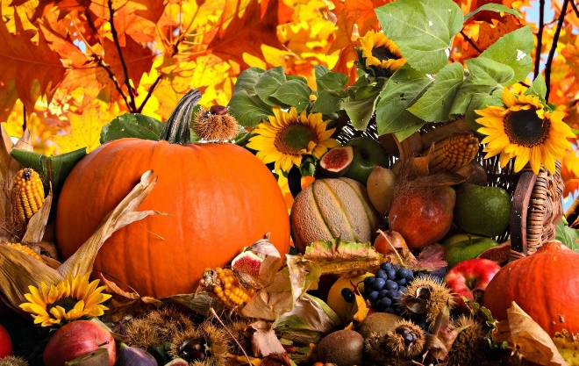

UPDATES October 2024

Tomorrow (Thursday 17th), we have a visiting brass Band during the afternoon. If you wish your child to participate in this exciting event, please can they bring in a £1 donation to cover the cost of the visitors.

On Tuesday 22nd October, it is The Monster Ball, kindly organised by our Friends Of Priory School team. Children will only be allowed to attend the disco if they bring back the permission slip that they have brought home. The children will need to come directly to the hall door, no earlier than the 5pm start time.

Also, on Tuesday 22nd October, Sunflower class will be leading our Harvest Liturgy to the other children in the school. As part of this, please can the children bring dry food donations into school as part of our Harvest collection. These will be delivered to our local foodbank.

On Friday 25th October, all Plymouth CAST schools will be celebrating the 10th anniversary of Plymouth CAST. All 35 schools in our Trust will be celebrating on this day and fundraising for the Catholic Children’s Society. Please can children bring donations in a sealed envelope and in return the children are wear their own clothes into school. As part of this day, the children will attend church, have a celebration assembly, take part in crafts to do withy the number 10 and culminating in a party.

We will send out a google form for families to sign up to suggest an item of party food that your child/children can bring into school on that day.

With many thanks

Mrs Maskell