Hello parents of Bluebell class,

Your children have all been working incredibly hard this half term and earning themselves a lot of house points!

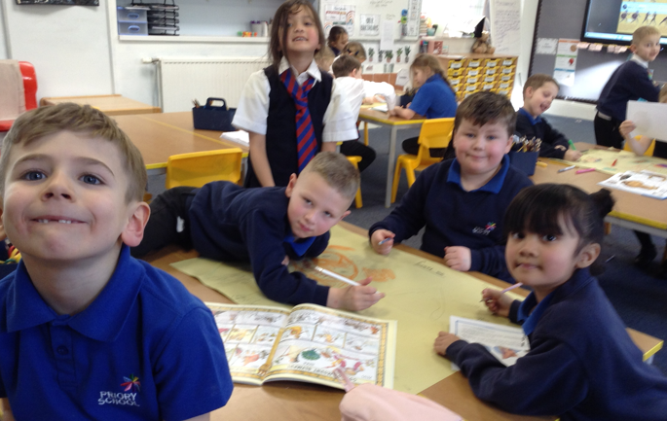
For our learning this half term, we have been doing some exciting cross-curricular learning all about Ancient Greece. This topic has been explored through English, History and DT lessons and the class will be taking part in an Olympic Games on Tuesday 6th February to celebrate the end of these topics. They will also be making some (miniature) Ancient Greek style pottery of their own.

In English we have been learning about Ancient Greek mythology and have created some fearsome Top Trumps monsters of our own. We finished this topic by looking at the myth of Daedalus and Icarus and the children wrote about their own invention/plan for escaping from the King’s maze. We have also started looking at the poem ‘The Owl and the Pussycat’, which has led to the children interviewing each other in role as the characters from the poem.
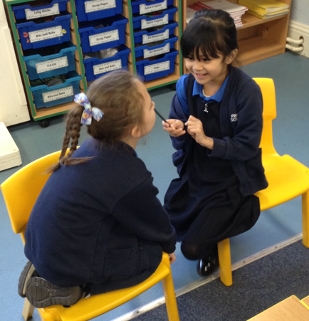

We are currently working with arrays in Maths in both year groups and have been using our new knowledge of grouping to help us with our times tables. We have been loving the Supermovers times tables videos to support us with this too.

Our science learning this half term has been looking at both materials (Y2) and states of matter (Y3) and has allowed us to undertake some fun and hands-on practical lessons. Our last lesson for the year 3’s was looking at the carbon dioxide in fizzy drinks. The children were tasked with making their own predictions for what would happen with the experiment as well as how we can ensure that we are keeping to a fair test. After a few examples that seemed to defy science we finally got the results that we were expecting for our fair test. Please ask your children for more details on their experiments! While the year 3’s were conducting this experiment, the year 2 children were manipulating a wide selection of different materials and objects to see if they were stretchy, bendy, twistable and squashable.

Our R.E lessons have revolved around the main theme of the Kingdom of God and so we have been looking at what this means as well as becoming ‘Scripture Detectives’ to delve deeper. The scripture from this unit has come from Matthew’s Gospel and we have used it to learn about the life and ministry of Jesus. Matthew uses parables and miracles to explain what the Kingdom of God is like, we looked in detail at the parable of the sower and what message this is telling us. Our prayer linked to the topic this half term has been the Our Father prayer so please encourage your children to keep practicing this one as well as the Hail Mary from last term. We have been working on our skills with finding Bible verses from references as well.
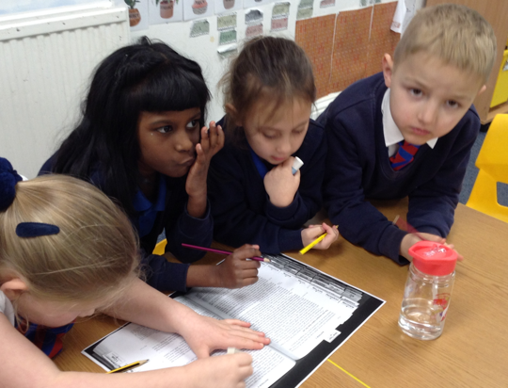

This has been a great half term in Bluebell class so far, keep up the good work everyone.

Miss Michael and the Bluebell team.

