RWI book level | Year R /Year 1/Year 2
Sound blending | - Book Bag Book or Wordless book  - Library ‘bedtime’ book
Red Ditty | - Storybook Black and white storybook to match their weekly RWI group book.  - Book bag book matched to their RWI story book out of the blue boxes in the KS1 corridor.  - Library ‘bedtime’ book  All children that are on RWI should have a reading record book.
Green
Purple
Pink
Orange
Yellow
Blue
Grey

Finished RWI
KS1 & KS2
- ‘AR Library book’

Children take termly Star Reading assessments and choose books within their level.
Teachers must keep a check on their quiz scores. They are aiming for at least 80% accuracy.

The school has a reading scheme where children achieve Minecraft Reading badges for reading and successfully quizzing on a set number of books for each level.

Sound Blending Books
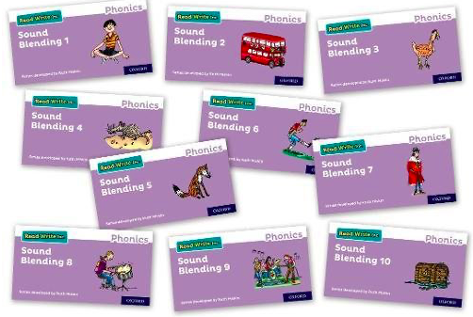 Your child is just beginning to blend sounds together to read words. They are going to bring home a sound blending book each week, linked to the sounds they are learning in school. Please spend 10 minutes a day reading these with your child and write in their reading record book to let us know how they have got on.
Encourage your child to look for the ‘special friends’ (more than one letter that makes just one sound such as: ‘ch’, ‘sh’ or ‘igh’)
They will then need to ‘Fred talk’ the words by breaking them down into individual sounds (phonemes) and then blending those sounds together i.e. c-a-t, sh-o-p.
Please send their book into school everyday as they may be asked to read with adults in school
Wordless Picture Books

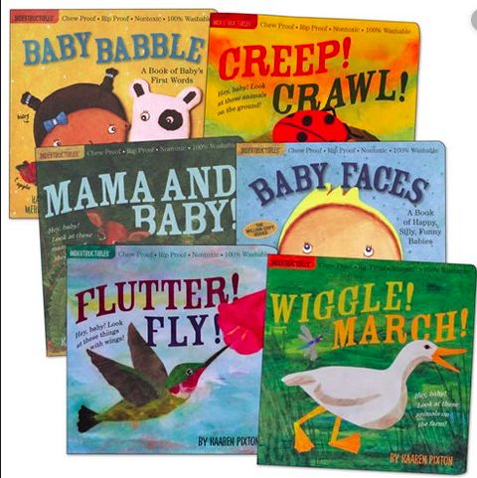Your child is just beginning to learn about reading. They are not yet familiar with all the sounds required to read but we want them to learn to enjoy books and how to handle them. Talk to your child about the right way to look at a book, how to turn pages with care. Look at the pictures together and talk about what is happening in each one. You can even make up your own stories to go with them!
Read Write Inc. Ditties

Your child is being introduced to short groups of CVC words using Ditty sheets. Each day your child will bring home a new Ditty for them to practise. Your child will have read the Ditty in school that day.
Please read the Ditty with your child everyday to reinforce their learning in school.
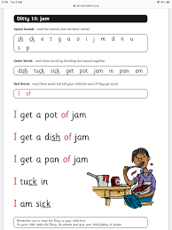
Please note whilst the Ditty sheets look similar each one is different and has a different number at the top.

Read Write Inc. Storybooks
Yellow/Blue/Grey

On Mondays, your child will bring home a black and white storybook linked to their Read Write Inc. phonics group. Please read this book each day and RETURN it to school on Friday.

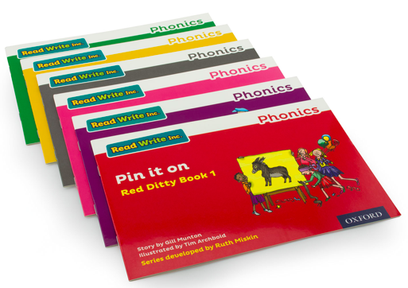 | Read Write Inc Storybook recommended 10 minute daily tasks.  Please write in their reading record book daily.
Monday | Look at the pictures and talk about what you can see happening.
Tuesday | Practise reading the green words, pointing to each one in turn. Talk about the meaning of any unknown words.
Wednesday | Practise reading the red words, pointing to each one in turn. Talk about the meaning of any unknown words.
Thursday | Listen to your child read the book. Encourage them to point to each word and to sound out and blend difficult words. If they find a sentence particularly tricky, encourage them to re-read it to develop fluency.
Friday | Please return the book to school every Friday.
Read Write Inc. Storybooks
Red Ditty/Green/Purple/Pink/Orange

On a 3 day cycle, your child will bring home a black and white storybook linked to their Read Write Inc. phonics group. Please read this book each day and RETURN it to school on the third day e.g. book goes home Monday and returns on Wednesday.

Read Write Inc Storybook recommended 10 minute daily tasks.
Please write in their reading record book daily.

Day 1 | Practise reading the green words, pointing to each one in turn. Talk about the meaning of any unknown words.  Practise reading the red words, pointing to each one in turn.
Day 2 | Listen to your child read the book. Encourage them to point to each word and to sound out and blend difficult words. If they find a sentence particularly tricky, encourage them to re-read it to develop fluency.
Day 3 | Please return the book to school.

Your child will be bringing home a black and white ‘Storybook’ linked to their current Read Write Inc. phonics group. They will be working on this book in their daily Read Write Inc. sessions in school. Please use the parent’s guide to help you structure your daily reading.

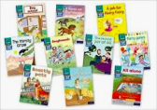 They will also bring home a ‘Book Bag book’ linked to their current reading level. It is important that your child reads books with sounds that are matched to their reading ability. Please support your child to read a couple of pages each day.

We would like you to spend 10 minutes each day with each book, recording in their reading record book daily to let us know how your child has got on. Please ensure your child brings all their reading books into school everyday, as they may be asked to read with an adult.

Thank you for supporting us to develop your child’s reading.

